Exercise 07: Multiscale Geographically Weighted Regression
Geographically Weighted Regression (GWR) is a powerful spatial regression method. It can take into account the spatial heterogeneity, to produce regression coefficients across space. Similar to multiple regression analysis, GWR can also consider multiple independent variables. As a variant of GWR, multiscale GWR (MGWR) uses a different number of neighborhoods for different independent variables to calculate the coefficients. There are three steps to conduct MGWR: (1) run simple linear regression (i.e., ordinary least squares), (2) run spatial heterogeneity test for the residuals, and (3) based on the results, run MGWR model if spatial heterogeneity is presented. In this exercise, you will learn how to use ArcGIS Pro to explore MGWR.
Topics covered in this exercise include:
- Conduct ordinary least squares regression analysis
- Interpret results from ordinary least squares regression
- Conduct MGWR
- Interpret MGWR coefficients

Data
This project contains one polygon vector data: ar_county_clean_son20.shp, representing the COVID-19 incident rate and associated health, socioeconomic, demographic, and climate variables for each county in Arkansas during the fall of 2020. The data was compiled from multiple data sources, such as New York GitHub database, County Health Ranking, and so on. Save it in the location you are choosing and unzip it by right-clicking on Exercise_7.zip. In the drop-down window, choose “Extract All”.

Step 1. Create a Project in ArcGIS Pro

- In the search bar at the left corner, type “ArcGIS Pro”. You will see the software “ArcGIS Pro”. Click on it, the ArcGIS Pro will be loaded.
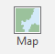
Note, this can also be done by navigating to All Apps followed by the ArcGIS Folder. Within the ArcGIS Folder, select ArcGIS Pro.
- Create a project to host your maps by clicking on the Map icon.
- The Create a New Project window should be shown. Define the name for your project. You can give any name that you prefer. Then click on Folder icon, find the location where you want to save your project.
- You do not need to change others.
- Click on OK.

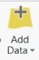
Step 2. Understand dependent and independent variables
You will first add ar_county_clean_son20.shp layers to the map within your project.
- Navigate to Map Tab. Click on Add Data button, navigate to the Exercise_7 folder.
- Highlight the ar_county_clean_son20.shp layer.
- Click on OK.

The data is loaded into ArcGIS Pro. Open the attribute table for the layer.
- Right-click on ar_county_clean_son20.shp layer, in the drop-down menu, select Attribute Table.

There are multiple attributes/fields in the table. As we are interested in how different factors impact COVID-19 spread in Arkansas, the dependent variable will be COVID-19 and the independent variable will be the different health, socioeconomic, demographic, and climate factors, which are described as follows.

Dependent variable
covid = COVID-19 incident rate for each county in Arkansas during the fall of 2020. The incident rate is calculated as the total cumulative COVID-19 cases during the fall of 2020 for each county divided by the total population for each county.

Independent variable
Adult_obes = Adult obesity: percentage of adults that report Body Mass Index (BM) >= 30.
EP_GROUPQ = % of persons in group quarters: percentage of persons in group quarters estimate.
_Non_Hisp = % of non-Hispanic: percentage of non-Hispanic Black people
Wind = 10-m wind speed in units of m/s.

Note, all of the dependent and independent variables are standardized.

Question 1. Which county has the highest COVID-19 incident rate? (4 Points) (Hint, right-click on the field of covid, in the drop-down menu, select on sort descending/sort ascending. The larger the number, the higher the incident rate)

Question 2. Which county has the highest Adult obesity? (4 Points)

Question 3. Which county has the highest % of persons in group quarters? (4 Points)

Question 4. Which county has the highest % of non-Hispanic black people? (4 Points)

Step 3. Conduct ordinary least squares regression analysis
Now, you are ready to conduct the first step, i.e., run the ordinary least squares regression.
- Navigate to Analysis Tab, click on Tools. Under Toolboxes, expand Spatial Statistics Tools.
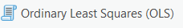
- Expand Modeling Spatial Relationships, then select Ordinary Least Squares (OLS) tool.
- In the Ordinary Least Squares (OLS) window, set Input Feature Class as “ar_county_clean_son20”, set Unique ID Field as “OBJECTID”, set Output Feature Class as “OLS_ar”, set Dependent Variable as “covid”.
- Under the Explanatory Variables group, check the box before Adult_obes, EP_GROUPQ, _Non_Hisp, and wind.
- Set Output Report File as “OLS_ar_report.pdf”
- You do not need to change others.
- Click Run to execute the OLS.
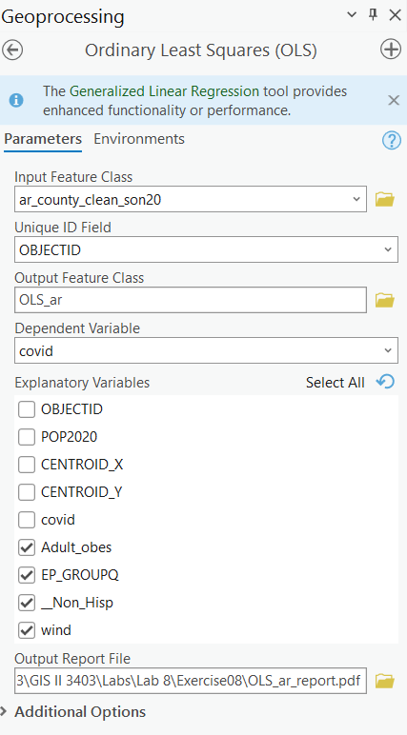

Wait for a while, the results should be automatically loaded into the Contents pane. The default map will be the standardized residuals from OLS model.
Open the attribute table for OLS_ar layer. There are new fields in the table.
Estimated = Estimated COVID-19 incident rate for each county based on the OLS model.
Residual = Actual COVID-19 incident rate (i.e., covid field) – Estimated COVID-19 incident rate (i.e., Estimated field). If the model is great enough, the residuals should not have spatial autocorrelation and heterogeneity.
StdResid = Standardized residual.
Now, you will interpret the results and assess the performance of the OLS model.
Find your OLS_ar_report.pdf file and open it.
The first page of the report tells the summary of OLS results.
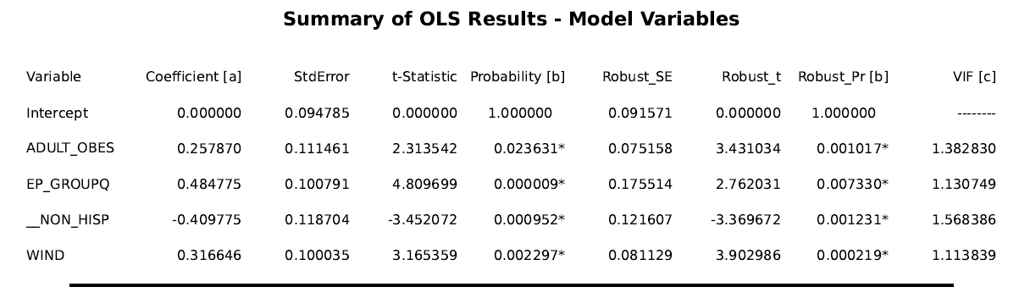
The coefficient column provides coefficient values for each independent variable and the Probability column tells whether the coefficient value is statistically significant or not. For example, the coefficient variable for Adult obesity is ~0.26, which is statistically significant (as the P-value is less than 0.05). This indicates that one unit increase in the standardized population with Adult obesity results in a 0.26 unit increase in the standardized COVID-19 incident rate.

Question 5. Which variable is the smallest positive contributor to the standardized COVID-19 incident rate? (4 Points)

The second page of the report tells the OLS Diagnostics. On this page, you will know the performance of the model.
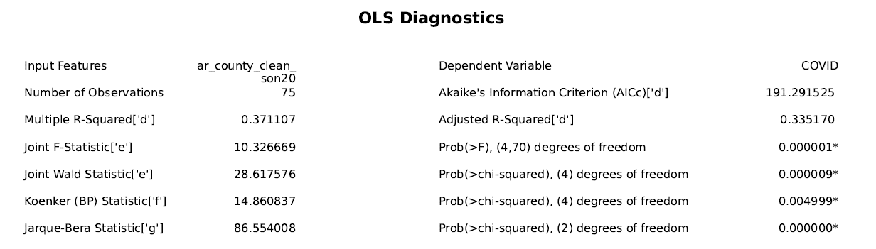
The adjusted R-Squared value is ~0.34, indicating that our selected four independent variables, including Adult obesity, % of persons in group quarters, % of non-Hispanic black people, and wind can explain 34% of the variability in the standardized COVID-19 incident rate. In general, the higher the adjusted R-Squared value, the better performance of the model.
The Koenker (BP) Statistic is statistically significant (P-value < 0.05), denoting that the residuals of the model have spatial heterogeneity. This implies that a geographically weighted regression model is required, as GWR can consider spatial heterogeneity.
Akaike's Information Criterion (AICc) can also assess the performance of the model. In general, the lower the AICc value, the better the model performance.

Question 6. Based on page 2, what is the Akaike's Information Criterion (AICc) value for the OLS model? (4 Points)

Step 4. Conduct multiscale geographically weighted regression analysis
The OLS results indicate that there is spatial heterogeneity in the residuals. Therefore, it is necessary to conduct MGWR.
- Navigate to Analysis Tab, click on Tools. Under Toolboxes, expand Spatial Statistics Tools.
- Expand Modeling Spatial Relationships, then select the Multiscale Geographically Weighted Regression tool.
- In the Multiscale Geographically Weighted Regression (MGWR) window, set Input Features as “ar_county_clean_son20”, set Dependent Variable as “covid”.
- Under the Explanatory Variables group, check the box before Adult_obes, EP_GROUPQ, _Non_Hisp, and wind.
- Do not check the box before the Scale Data, as the data has been standardized.
- set Output Features as “MGWR_ar”.
- Set Neighborhood Type as “Distance Band”, set Neighborhood Selection Method as “Golden Search” and Distance Unit as “Meters”.
- Expand Additional Options, make sure the Local Weighting Scheme is “Bisquare”.
- You do not need to change others.
- Click Run to execute the MGWR.
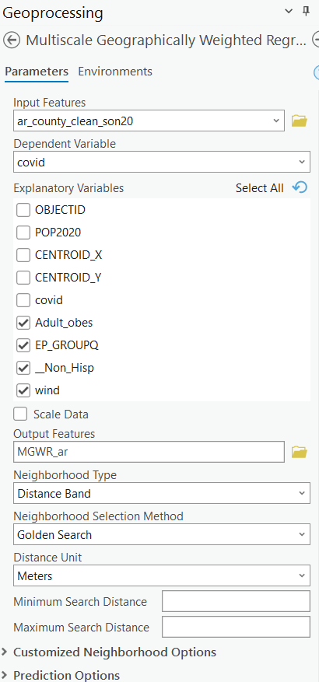

Wait for a while, the results should be automatically loaded into the Contents pane. The default maps will be the coefficient map and the corresponding significance map for each independent variable. The standardized residual map is also displayed. Note, there is a coefficient value for each county for each independent variable, which is different compared to that derived from the OLS model.
Now, you will interpret the results and assess the performance of the OLS model.

- Click on View Details at the low-right corner box.

The Multiscale Geographically Weighted Regression window should be shown.

The first table tells the summary statistics for coefficient estimates.
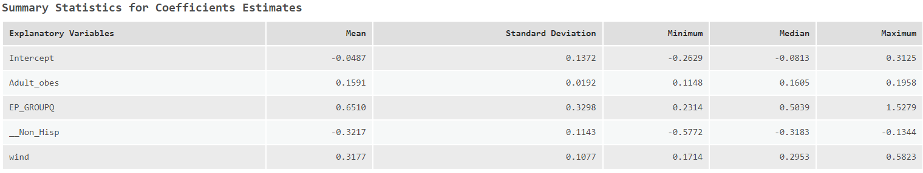

The column of Mean tells the average coefficient value of 75 counties for each independent variable. As different counties have different coefficient values, the table also provides the minimum and maximum coefficient values for each independent variable.

Question 7. Compared to the coefficient values derived from OLS, does the sign of the coefficient value for each independent variable change? (4 points)

The second table is for model diagnostics. This table not only provides the results for MGWR, but also for GWR. In this exercise, we will focus on MGWR.
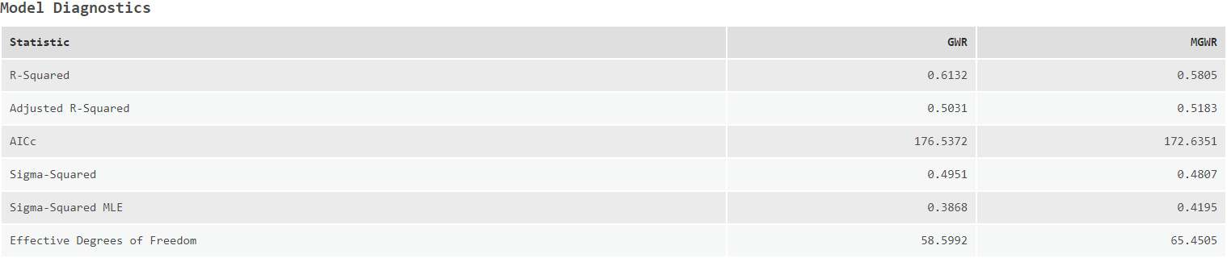
Based on the table, answer the following question.

Question 8. What is the Adjusted R-Squared value for MGWR? How about AICc? (4 points)

Question 9. Compared to the Adjusted R-Squared and AICc derived from OLS, which model performs better? (4 points)

Scroll down to the last table, depicting the bandwidth statistics summary. If bandwidth varies among different independent variables, the MGWR is appropriate. If the bandwidth for different independent variables is consistent, then GWR is more appropriate.
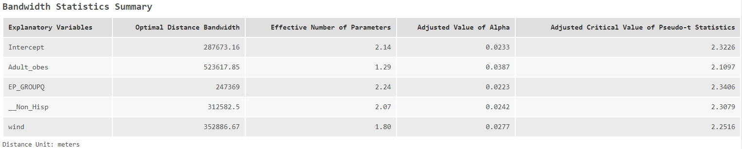
Based on the Optimal Distance Bandwidth column, answer the following question.

Question 10. Is our choice of MGWR more appropriate compared to the GWR? Why? (4 points)

Step 4. Interpret spatial coefficient values derived from MGWR
Now, you will start to explore how the impacts of different factors on COVID-19 change spatially.
- Navigating back to the map.
- In the Contents pane, only check the box before Coefficient (wind) and significance (wind). Turn off all other layers.
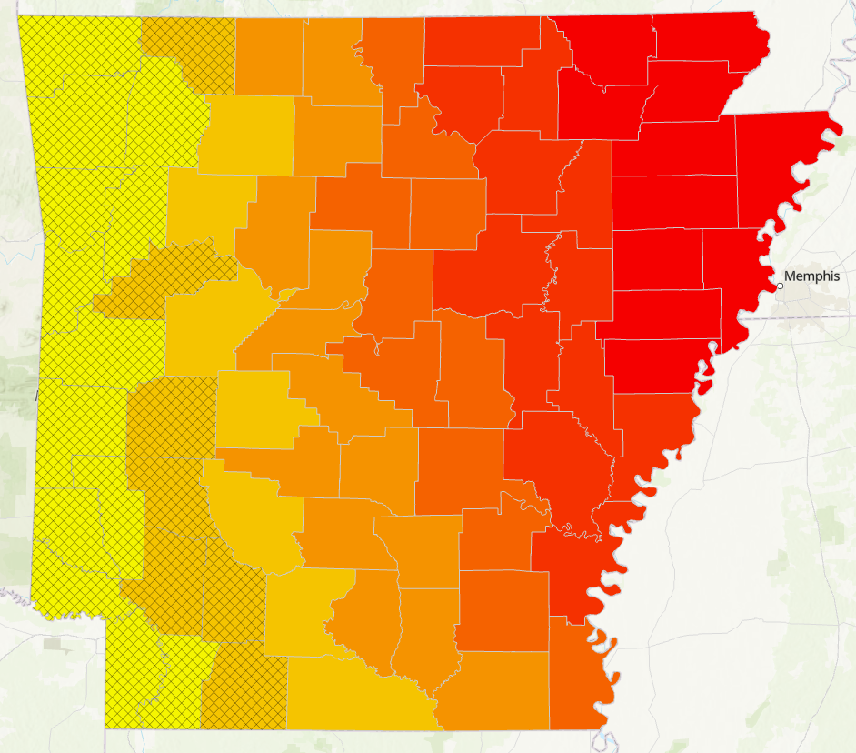

The shaded area indicates the coefficients in those counties are not statistically significant at the 5% level. This denotes the coefficient values are not reliable for that county. In general, we only focus on the coefficients that are statistically significant.

Based on the coefficient and significance map for wind. Answer the following question.

Question 11. Describe how coefficients of wind change across counties. (3 points)

Deliverable 1. Create a map layout layer and submit your layout in PNG format. Your layout should include: (3 points)
- Four coefficient and significance maps for four independent variables.
- A proper title
- A proper legend or four legends
- A proper North arrow
- A proper scale bar

Your layout should look like the following layout.
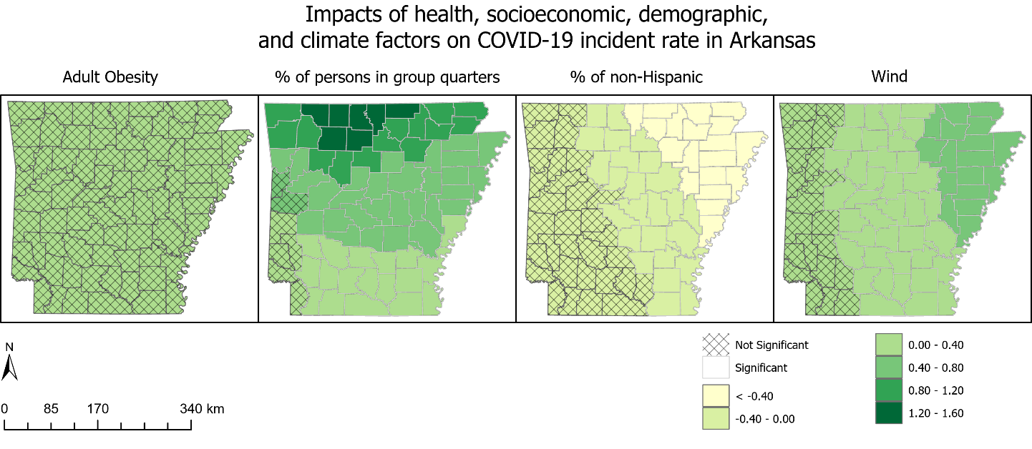

Based on deliverable 1, answer the following question.

Question 12. Do the four independent variables have the same impacts on the COVID-19 incident rate? What are their spatial patterns? Are they in your expectation? Why? (6 points)

END OF EXERCISE

Homework
Please submit a word file with 12 questions and 1 deliverables. Please submit through Blackboard.

